**Ideation Phase**

**Define the Problem Statements**

|  |  |
| --- | --- |
| Date | 16 NOVEMBER 2022 |
| Team ID | PNT2022TMID51798 |
| Project Name | IoT Based Smart Crop Protection System For Agriculture |
| Maximum Marks | 2 Marks |

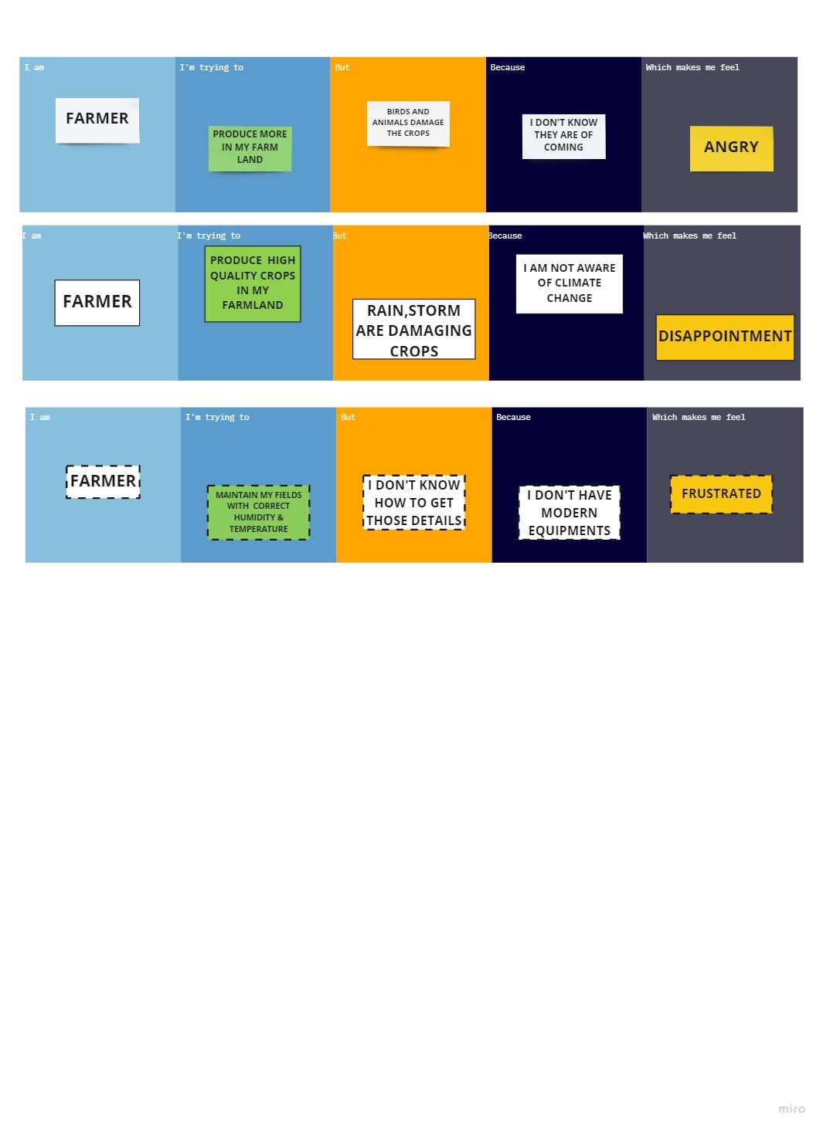**Customer Problem Statement Template:**

|  |  |  |  |  |  |
| --- | --- | --- | --- | --- | --- |
| **Problem Statement (PS)** | **I am (Customer)** | **I’m trying to** | **But** | **Because** | **Which makes me feel** |
| PS-1 | farmer | Produce more in my farmland | Birds and animals damage the crops | I don’t know they are coming | angry |
| PS-2 | farmer | Produce high qualitycrops in my farmland | Rain,storm are damaging crops | I am not aware of  Climate change | disappoinment |
| PS-3 | farmer | Maintain my fields with correct humidity &temperature | I don’t know how to get those details | I don’t have modern equipments | frustrated |